**C:\Program Files\Microsoft Office\MEDIA\CAGCAT10\j0285750.wmf**

**Project 3 Manual**

**Services and Dependencies**

**Prepared By:** Shreeman Kuppa Jayaram

**Date:** 11/10/2023

Contents

INTRODUCTION 3

NameCheap 3

AWS S3 Bucket 3

AWS CloudFront 3

AWS Route 53 3

AWS Certificate Manager 3

FLOW CHART 4

Figure 1: Flowchart diagram of interactions between different services 4

ACKNOWLEDGEMENTS 4

# INTRODUCTION

The manual describes a list of all the services and their purpose in creating a static website on AWS S3 with static hosting and CloudFront. It also outlines the order and dependencies of the services used.

## NameCheap

Namecheap is a user-friendly website to register and manage domain names of the website for the project, in this case cs412skuppajayaram.xyz. Any user can publicly access the website by typing it in the search bar. In addition, NameCheap is necessary to validate Secure Socket Layer (SSL) certificates created by AWS Certificate Manager as a domain owner by adding nameservers created by AWS Route 53 and establishing trust in them. Hence, NameCheap controls Domain Name System (DNS) and ensures a secured connection to the website domain. In addition, NameCheap connects with the AWS S3 Bucket through a CNAME record containing the endpoint URL from S3 Bucket. We can set the Time-To-Live (TTL) on NameCheap to 5 minutes, which is the amount of time the DNS record is valid after it has been cached and before re-retrieving new data.

## AWS S3 Bucket

AWS S3 Bucket is a key element used for hosting static website content, in our case the HTML, CSS, and JS of the personal portfolio repository from CSCE 315. It is needed to upload files and configure permissions for public read access to the website ensuring object ownership is managed by user preferences.

## AWS CloudFront

AWS CloudFront is a fast Content Delivery Network (CDN) service used to securely deliver data with low latency and high transfer rates in our environment. By creating an AWS CloudFront distribution, the domain can redirect from HTTP to HTTPS connections for improved security and attach SSL certificates created by AWS Certificate Manager to allow secure data transit. In addition, CloudFront supports the default domain name in NameCheap and the creation of alternative domain names (*.cs412skuppajayaram.xyz). In general, CloudFront connects with the S3 bucket files for navigation and caches content at edge locations to provide a faster user experience.

## AWS Route 53

AWS Route 53 is a highly scalable and available DNS that can translate human-readable domain names created by Namecheap (in this case cs412skuppajayaram.xyz) into IP addresses. Hence, the user can set user-friendly domain names and have Route 53 perform DNS resolution and enable access to right AWS infrastructure like the S3 bucket and CloudFront Distribution. In addition, Route 53 sets up nameservers for the publicly hosted zone of the domain so that DNS records are managed, and traffic is routed to the right AWS resources, thereby connecting the registered domain and AWS-hosted website. Route 53 also creates and supports alias records, allowing A records with the www subdomain appended before the Namecheap domain name as alias to CloudFront distribution created.

## AWS Certificate Manager

AWS Certificate Manager creates and manages SSL certificates for secure connections of the domain in a simple way. It automates provisioning certificates in the long-term and reduces the complexity of managing cryptographic keys by the user. Once setup, AWS Certificate Manager can create records for the NameCheap domain with appended domains (*.cs412skuppajayaram.xyz) in one instance and provide secured access to the websites.

# FLOW CHART

**Figure 1** below demonstrates a flowchart outlining the main sequential flow (in dotted arrows) and the dependencies (in solid arrows) of the interaction between different services. For solid arrows, the location of the service box closest to the text indicates that the service uses information from the other service as input.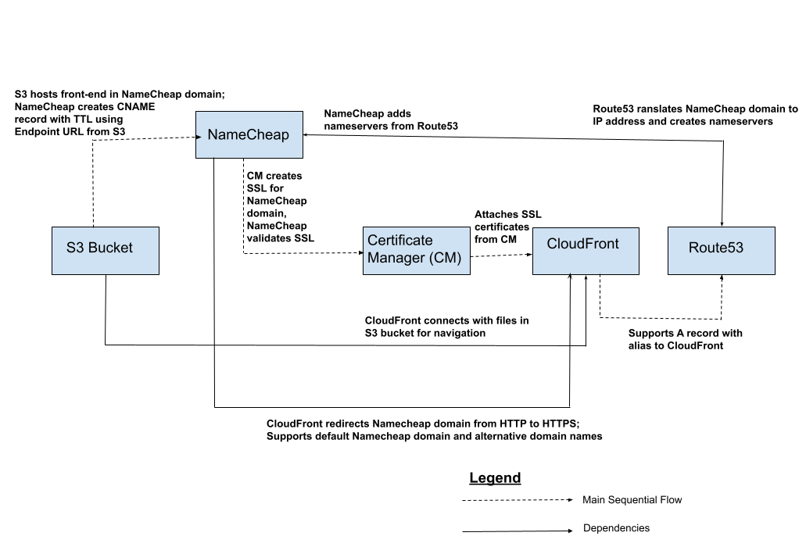

### Figure 1: Flowchart diagram of interactions between different services

# ACKNOWLEDGEMENTS

The services used in the documentation include NameCheap and multiple AWS resources.

The flowchart was created using Google Drawings.

The template for the user manual was obtained from <https://www.docformats.com/instruction-manual-template/>.